**LAN CARDS**

A **LAN Card** is the network interface card that is used by the device to communicate with the network. LAN Cards can be classified as wireless or wired. Wired LAN Cards are also called conductive LAN Cards.

LAN Cards are also referred to as Network Interface Controllers (NIC) as well as many other descriptive names. Any device that connects to the network needs a version of a LAN Card, whether it be a computer, a printer, a game console, a television, a smart phone, or one of the many Internet of Things (IoT) that are network compatible, like a refrigerator or thermostat. All of these devices may be able to connect to a network with the correct LAN Card.

**Functions-**

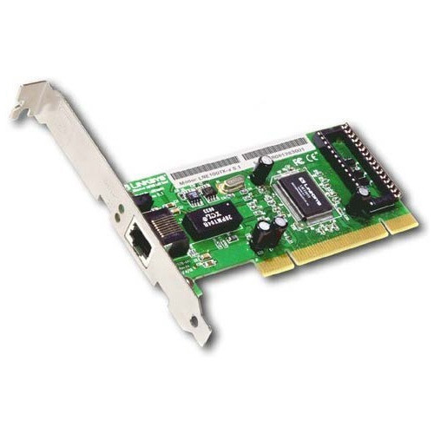Computers processes information based on their operating system and programming. To communicate with another device, that information must be translated into a common protocol for transport on the network so that the receiving device can translate that information into usable data. The function of a LAN Card is to encode the data into packets for transport and to make sure the packets are transported to the right destination. It also provides the physical connection to the network to transmit that data utilizing the proper protocols.

**RJ 45 CONNNECTOR**

RJ45 is a type of connector commonly used for [Ethernet](https://techterms.com/definition/ethernet) networking. It looks similar to a telephone jack, but is slightly wider. Since Ethernet cables have an RJ45 connector on each end, Ethernet cables are sometimes also called RJ45 cables.

The "RJ" in RJ45 stands for "registered jack," since it is a standardized networking interface. The "45" simply refers to the number of the interface standard. Each RJ45 connector has eight pins, which means an RJ45 cable contains eight separate wires. If you look closely at the end of an Ethernet cable, you can actually see the eight wires, which are each a different color. Four of them are solid colors, while the other four are striped.

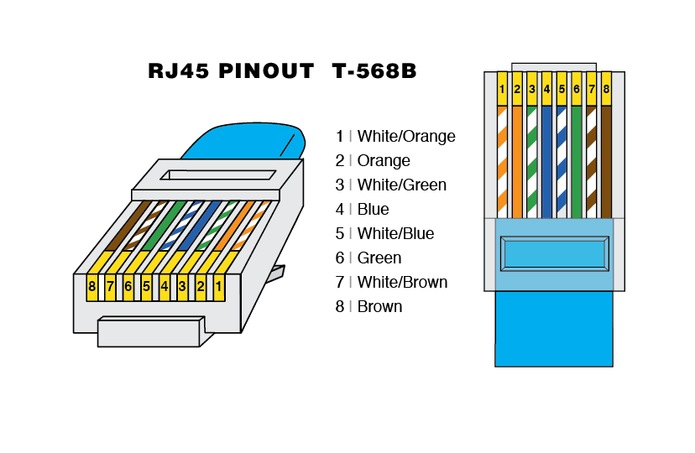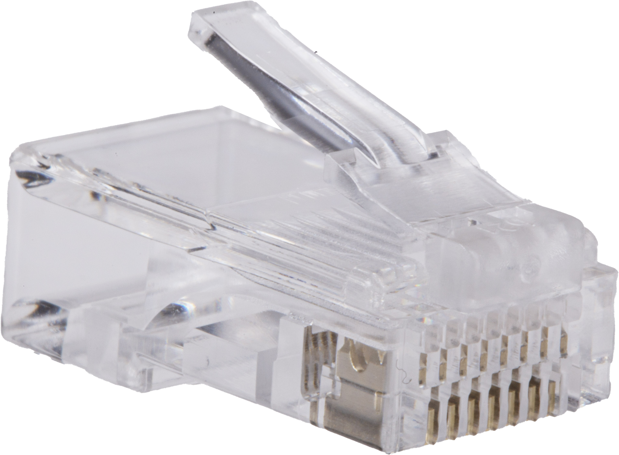

**SWITCH**

Switches are networking devices operating at layer 2 or a data link layer of the OSI model. They connect devices in a network and use packet switching to send, receive or forward data packets or data frames over the network.

A switch has many ports, to which computers are plugged in. When a data frame arrives at any port of a network switch, it examines the destination address, performs necessary checks and sends the frame to the corresponding device(s).It supports unicast, multicast as well as broadcast communications.

## Features of Switches

* A switch operates in the layer 2, i.e. data link layer of the OSI model.
* It is an intelligent network device that can be conceived as a multiport network bridge.
* It uses MAC addresses (addresses of medium access control sublayer) to send data packets to selected destination ports.
* It uses packet switching technique to receive and forward data packets from the source to the destination device.
* It is supports unicast (one-to-one), multicast (one-to-many) and broadcast (one-to-all) communications.
* Transmission mode is full duplex, i.e. communication in the channel occurs in both the directions at the same time. Due to this, collisions do not occur.
* Switches are active devices, equipped with network software and network management capabilities.
* Switches can perform some error checking before forwarding data to the destined port.
* The number of ports is higher – 24/48

## Types of Switches

Unmanaged Switch,Managed Switch,LAN Switch , PoE Switch

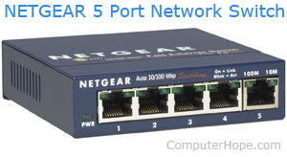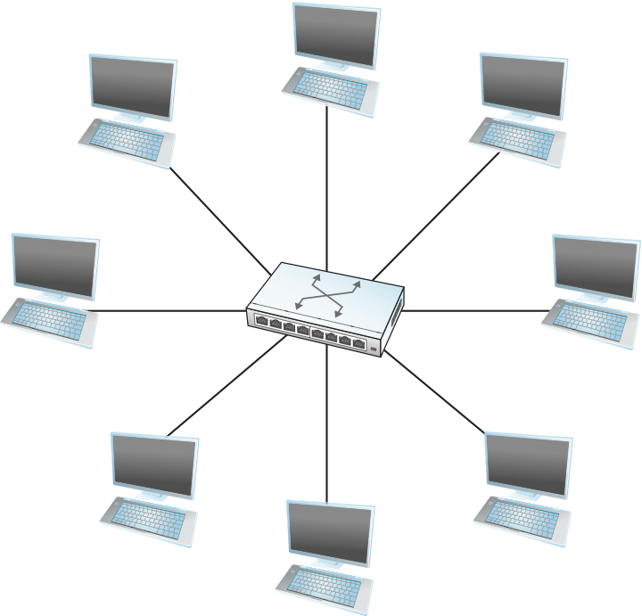

**CAT 5 CABLE**

Alternatively known as an **Ethernet cable** or **LAN cable**, a **Cat 5** or **category 5** is a [network](https://www.computerhope.com/jargon/n/network.htm) cable that consists of four twisted pairs of copper wire terminated by an [RJ-45](https://www.computerhope.com/jargon/r/rj45.htm) connector. The picture shows an example of a Cat 5 cable.

Cat 5 cable is used in home and business networks, providing data transmission speeds of up to 100 [Mbps](https://www.computerhope.com/jargon/m/mbps.htm). The maximum recommended length of a Cat 5 cable is 100 meters. Exceeding this length without the aid of a bridge or other network device could cause network issues, including data packet loss and data transmission speed degradation.

A Cat 5 cable contains 8 wires and has a specific wire order. If the wires are in a different order, the cable does not work. There are two standards, T568A and T568B, for the order of the wires. Each standard is similar in performance and does not provide an advantage over the other. However, you must use the same wire order on each end of the Cat 5 cable.

The tables and images below display the color and order of the wires in a Cat 5 cable, for each wiring standard.

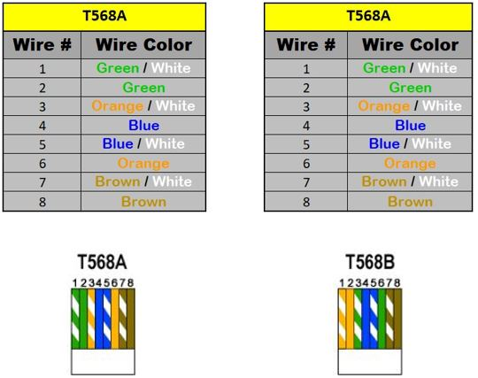

**CABLE TESTER**

A **cable tester** is a device used to test the strength and connectivity of a particular type of cable or other wired assemblies. There are many different types of cable testers. Each of them can test a specific type of cable or wire (some can test different types of cables or wires). A cable tester can test whether a cable or wire is set up properly, connected correctly, and the communication strength between the source and destination. The picture is an example of a cable tester from TRENDnet.

For computers, one of the most common types of cable testers used is for testing [Cat 5](https://www.computerhope.com/jargon/c/cat5.htm), Cat 5e, and Cat 6 network cables. Because so many different types of data are transmitted over a network cable, a proper connection needs to be established between the computer and server. Also, make sure the signal strength is adequate for transmitting data and that there is no outside interference. A cable tester can test for these factors and verify the network cables connections are correct and work for the intended purpose.

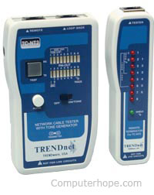

**Crimping tool**

A crimping tool is a device that is used to make cold weld joints between wires and a connector through deforming one or both of them to hold the other. A special connector is used to join metals together. The weld joint properties (mechanical and electrical) are strong as the parent materials when the tool works and offer some result, which is known as crimp. An instance of crimping is to affixing a connector to the end of a wire. For example, a crimping tool is used to create phone cable sand network cables to combine RJ-11 and RJ-45 connectors to both ends of the phone or Cat 5 cable. The below picture is an example of RJ-11 (6-pin) and RJ-45 (8-pin) crimping tools.

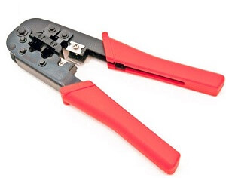

## How to use a Crimping Tool?

First of all, the wire that you want to crimp, bandage it and attach the connector. Then, with the help of matching wire gauge ratings, the right die head for the connector will have to select for crimping tools with interchangeable dies. The groove must be properly matched for die less crimpers. In the last, take out the newly crimped connector with the help of applying pressure. And, for checking your connection is secure or not, give a few tugs.

**HUB AND SWITCH**

## **Hubs**

A hub is a physical layer networking device which is used to connect multiple devices in a network. They are generally used to connect computers in a LAN.

A hub has many ports in it. A computer which intends to be connected to the network is plugged in to one of these ports. When a data frame arrives at a port, it is broadcast to every other port, without considering whether it is destined for a particular destination or not.

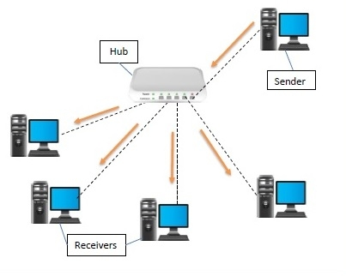

## **Types of Network Hubs**

There are three types of network hubs: passive, active, and intelligent.

Passive hubs or concentrators do not amplify or regenerate incoming signals before rebroadcasting them to the network. They do not improve the performance of local area networks (LANs), and may limit maximum media distances. Typically, passive hubs are connected to other devices in a star configuration.

Active hubs or multiport repeaters amplify the incoming electrical signals that contain data packets. They maximize network media distances and follow the same rules as repeaters. Although active hubs do not prioritize data packets, they can be configured as firewalls to examine them. If a received signal is too weak for rebroadcasting, active network hubs apply retiming and resynchronization techniques.

Intelligent hubs work like active hubs and include remote management capabilities. They also provide flexible data rates to network devices.

**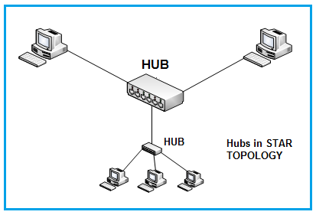**

### **Features of Hub**

* It acts with shared bandwidth and broadcasting.
* It includes only one collision domain and broadcast domain.
* It works at the physical layer of the OSI model and also offers support for half-duplex transmission mode.
* It cannot create a virtual LAN and does not support spanning tree protocol.
* Furthermore, mainly packet collisions occur inside the hub.
* It also has a feature of flexibility, which means it includes a high transmission rate to different devices.

### Applications of Hub

The important applications of a hub are given below:

* Hub is used to create small home networks.
* It is used for network monitoring.
* They are also used in organizations to provide connectivity.
* It can be used to create a device that is available thought out of the network.

**switches-**

**Switches are networking devices operating at layer 2 or a data link layer of the OSI model. They connect devices in a network and use packet switching to send, receive or forward data packets or data frames over the network.**

A switch has many ports, to which computers are plugged in. When a data frame arrives at any port of a network switch, it examines the destination address, performs necessary checks and sends the frame to the corresponding device(s).It supports unicast, multicast as well as broadcast communications.

## **Types of Switches**

There are variety of switches that can be broadly categorised into 4 types −

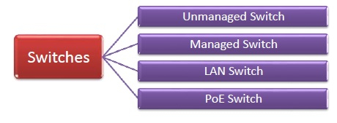

nmanaged Switch **− These are inexpensive switches commonly used in home networks and small businesses. They can be set up by simply plugging in to the network, after which they instantly start operating. When more devices needs to be added, more switches are simply added by this plug and play method. They are referred to as u managed since they do not require to be configured or monitored.**

* Managed Switch − These are costly switches that are used in organisations with large and complex networks, since they can be customized to augment the functionalities of a standard switch. The augmented features may be QoS (Quality of Service) like higher security levels, better precision control and complete network management. Despite their cost, they are preferred in growing organizations due to their scalability and flexibility. Simple Network Management Protocol (SNMP) is used for configuring managed switches.
* LAN Switch − Local Area Network (LAN) switches connects devices in the internal LAN of an organization. They are also referred as Ethernet switches or data switches. These switches are particularly helpful in reducing network congestion or bottlenecks. They allocate bandwidth in a manner so that there is no overlapping of data packets in a network.
* PoE Switch − Power over Ethernet (PoE) switches are used in PoE Gogabit Ethernets. PoE technology combine data and power transmission over the same cable so that devices connected to it can receive both electricity as well as data over the same line. PoE switches offer greater flexibility and simplifies the cabling connections

## **Difference between Hub and Switch**

The following table highlights the major differences between a Hub and a Switch −

| Key | Hub | Switch |
| --- | --- | --- |
| Objective | The main objective of a Hub is to transmit the signal to a port, which will respond to where the signal was received. | A switch allows you to set up and terminate connections as needed. |
| Layer | Hubs operate at the Physical Layer. | Switches function at the Data Link Layer. |
| Transmission Type | Hubs use broadcast type transmission. | Switches use unicast, multicast as well as broadcast type transmission. |
| Ports | Hub can have maximum 4 ports. | Switch can have 24 to 28 ports. |
| Collision Domain | There is only one collision domain in a Hub. | In a Switch, each port has its own collision domain. |
| Packet Filtering | Hubs do not provide packet filtering. | Switches provide packet filtering. |
| Transmission Mode | Hub uses half duplex transmission mode. | Switch uses full duplex transmission mode. |

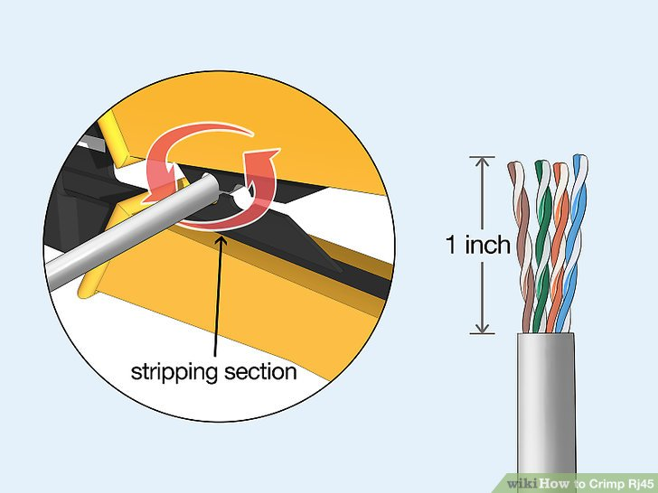

**Crimping Cat 5cable with rj45 connecto**r

1

**Strip the cable back 1 inch (25 mm) from the end.** Insert the cable into the stripper section of the tool and squeeze it tight. Then, rotate the crimping tool around the cable in a smooth and even motion to create a clean cut. Keep the tool clamped and pull away towards the end of the wire to remove the sheathing.[[1]](https://www.wikihow.com/Crimp-Rj45" \l "_note-1)

* The stripping section is a round hole near the handle of the tool.
* The sheathing should come off cleanly, leaving the wires exposed.

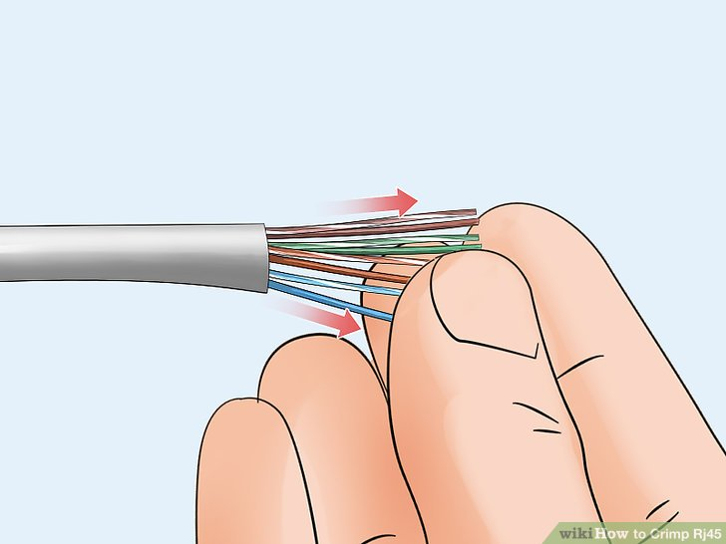

2

**Untwist and straighten the wires inside of the cable.** Inside of the cable you’ll see a bunch of smaller wires twisted together. Separate the twisted wires and straighten them out so they’re easier to sort into the right order.[[2]](https://www.wikihow.com/Crimp-Rj45" \l "_note-2)

* Cut off the small plastic wire separator or core so it’s out of the way.
* Don’t cut off or remove any of the wires or you won’t be able to crimp them into the connector.

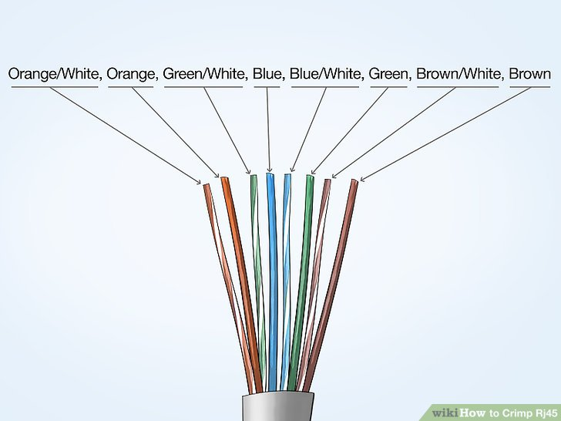

3

**Arrange the wires into the right order.** Use your fingers to put the wires in the correct order so they can be properly crimped. The proper sequence is as follows from left to right: Orange/White, Orange, Green/White, Blue, Blue/White, Green, Brown/White, Brown.[[3]](https://www.wikihow.com/Crimp-Rj45" \l "_note-3)

* There are 8 wires in total that need to be arranged in the right sequence.
* Note that the wires labeled Orange/White or Brown/White indicate the small wires that have 2 colors.

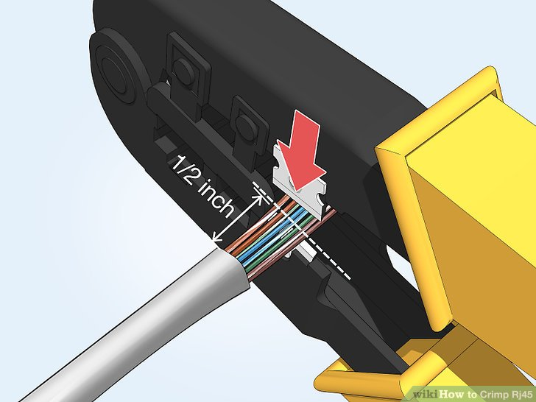

4

**Cut the wires into an even line 1⁄2 inch (13 mm) from sheathing.** Hold the wires with your thumb and index finger to keep them in order. Then, use the cutting section of the crimping tool to cut them into an even line.[[4]](https://www.wikihow.com/Crimp-Rj45" \l "_note-4)

* The cutting section of the tool will resemble wire cutters.
* The wires must be in an even line to be crimped into the RJ-45 connector properly. If you cut them in an uneven line, move further down the wires and cut them again.

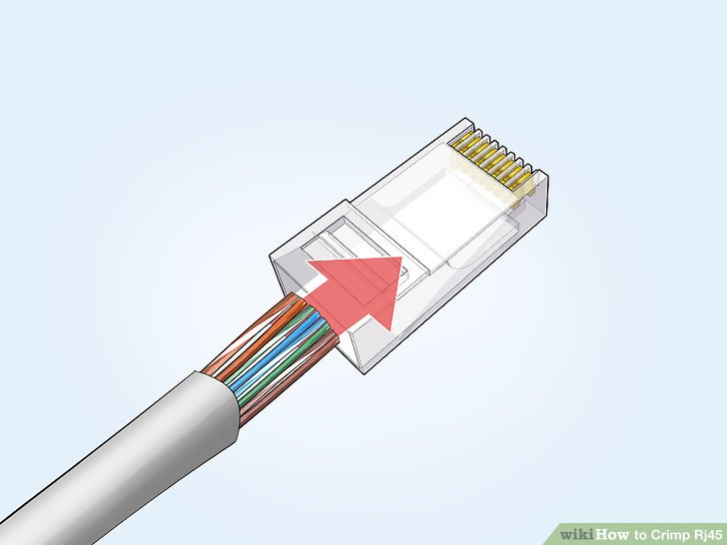

5

**Insert the wires into the RJ-45 connector.** Hold the RJ-45 connector so the clip is on the underside and the small metal pins are facing up. Insert the cable into the connector so that each of the small wires fits into the small grooves in the connector.[[5]](https://www.wikihow.com/Crimp-Rj45" \l "_note-5)

* The sheathing of the cable should fit just inside of the connector so it’s past the base.
* If any of the small wires bend or don’t fit into a groove correctly, take the cable out and straighten the wires with your fingers before trying again.
* The wires must be inserted in the correct order and each wire must fit into a groove before you crimp the connector.

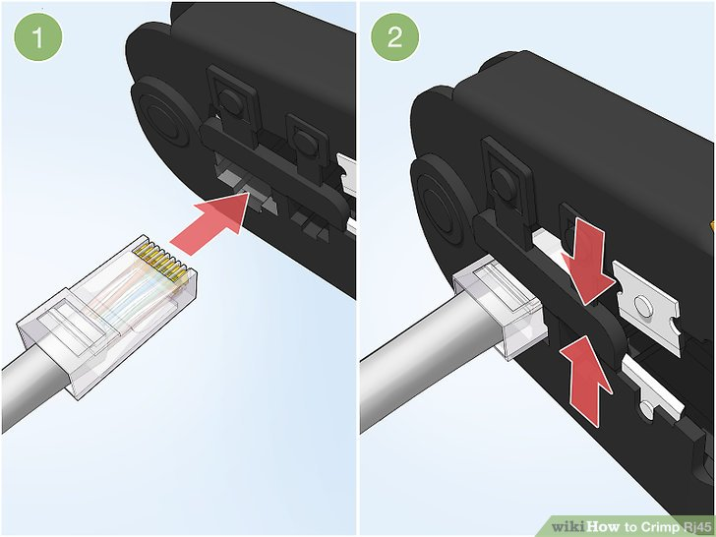

6

**Stick the connector into the crimping part of the tool and squeeze twice.** Insert the connector in the crimping section of the tool until it can’t fit any further. Squeeze the handles to crimp the connector and secure the wires. Release the handles, then squeeze the tool again to make sure all of the pins are pushed down.

* The crimping tool pushes small pins in the grooves down onto the wires to hold and connect them to the RJ-45 connector.

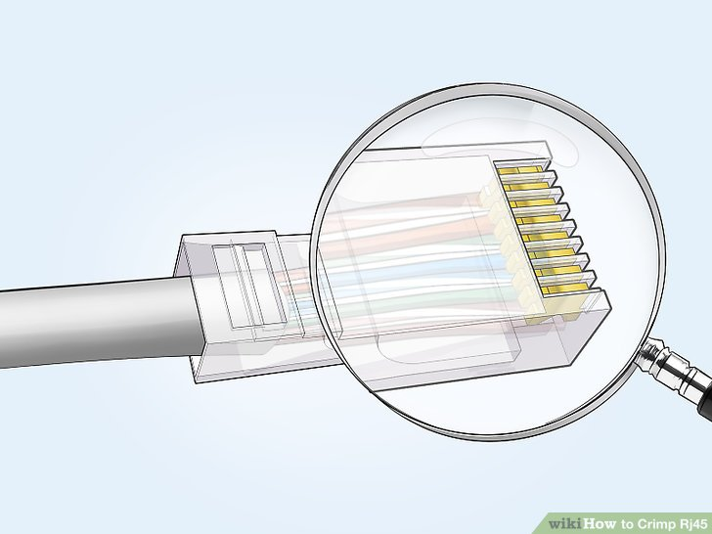

7

**Remove the cable from the tool and check that all of the pins are down.** Take the connector out of the tool and look at the pins to see that they’re all pushed down in an even line. Lightly tug at the connector to make sure it’s attached to the cable.

* If any of the pins aren’t pushed down, put the wire back into the crimping tool and crimp it again.

**STUDY OF TOPOLOGY**

# What is Topology?

Topology defines the structure of the network of how all the components are interconnected to each other. There are two types of topology: physical and logical topology.

Physical topology is the geometric representation of all the nodes in a network.

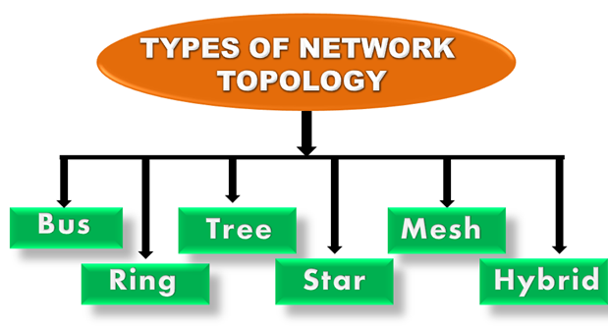

## Bus Topology

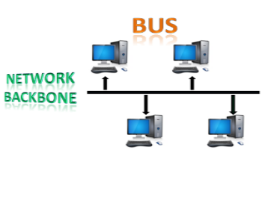

* The bus topology is designed in such a way that all the stations are connected through a single cable known as a backbone cable.
* Each node is either connected to the backbone cable by drop cable or directly connected to the backbone cable.
* When a node wants to send a message over the network, it puts a message over the network. All the stations available in the network will receive the message whether it has been addressed or not.
* The bus topology is mainly used in 802.3 (ethernet) and 802.4 standard networks.
* The configuration of a bus topology is quite simpler as compared to other topologies.
* The backbone cable is considered as a "single lane" through which the message is broadcast to all the stations.
* The most common access method of the bus topologies is CSMA (Carrier Sense Multiple Access).

### Advantages of Bus topology:

* Low-cost cable: In bus topology, nodes are directly connected to the cable without passing through a hub. Therefore, the initial cost of installation is low.
* Moderate data speeds: Coaxial or twisted pair cables are mainly used in bus-based networks that support upto 10 Mbps.
* Familiar technology: Bus topology is a familiar technology as the installation and troubleshooting techniques are well known, and hardware components are easily available.
* Limited failure: A failure in one node will not have any effect on other nodes.

### Disadvantages of Bus topology:

* Extensive cabling: A bus topology is quite simpler, but still it requires a lot of cabling.
* Difficult troubleshooting: It requires specialized test equipment to determine the cable faults. If any fault occurs in the cable, then it would disrupt the communication for all the nodes.
* Signal interference: If two nodes send the messages simultaneously, then the signals of both the nodes collide with each other.
* Reconfiguration difficult: Adding new devices to the network would slow down the network.
* Attenuation: Attenuation is a loss of signal leads to communication issues. Repeaters are used to regenerate the signal.

## Ring Topology

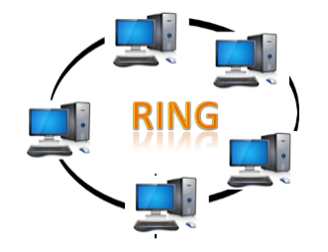

* Ring topology is like a bus topology, but with connected ends.
* The node that receives the message from the previous computer will retransmit to the next node.
* The data flows in one direction, i.e., it is unidirectional.
* The data flows in a single loop continuously known as an endless loop.
* It has no terminated ends, i.e., each node is connected to other node and having no termination point.
* The data in a ring topology flow in a clockwise direction.
* The most common access method of the ring topology is token passing.
  + Token passing: It is a network access method in which token is passed from one node to another node.
  + Token: It is a frame that circulates around the network.

### Working of Token passing

* A token moves around the network, and it is passed from computer to computer until it reaches the destination.
* The sender modifies the token by putting the address along with the data.
* The data is passed from one device to another device until the destination address matches. Once the token received by the destination device, then it sends the acknowledgment to the sender.
* In a ring topology, a token is used as a carrier.

### Advantages of Ring topology:

* Network Management: Faulty devices can be removed from the network without bringing the network down.
* Product availability: Many hardware and software tools for network operation and monitoring are available.
* Cost: Twisted pair cabling is inexpensive and easily available. Therefore, the installation cost is very low.
* Reliable: It is a more reliable network because the communication system is not dependent on the single host computer.

### Disadvantages of Ring topology:

* Difficult troubleshooting: It requires specialized test equipment to determine the cable faults. If any fault occurs in the cable, then it would disrupt the communication for all the nodes.
* Failure: The breakdown in one station leads to the failure of the overall network.
* Reconfiguration difficult: Adding new devices to the network would slow down the network.
* Delay: Communication delay is directly proportional to the number of nodes. Adding new devices increases the communication delay.

## Star Topology

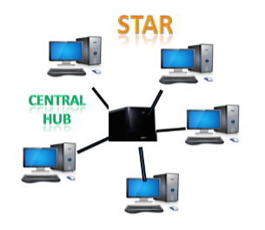

* Star topology is an arrangement of the network in which every node is connected to the central hub, switch or a central computer.
* The central computer is known as a server, and the peripheral devices attached to the server are known as clients.
* Coaxial cable or RJ-45 cables are used to connect the computers.
* Hubs or Switches are mainly used as connection devices in a physical star topology.
* Star topology is the most popular topology in network implementation.

### Advantages of Star topology

* Efficient troubleshooting: Troubleshooting is quite efficient in a star topology as compared to bus topology. In a bus topology, the manager has to inspect the kilometers of cable. In a star topology, all the stations are connected to the centralized network. Therefore, the network administrator has to go to the single station to troubleshoot the problem.
* Network control: Complex network control features can be easily implemented in the star topology. Any changes made in the star topology are automatically accommodated.
* Limited failure: As each station is connected to the central hub with its own cable, therefore failure in one cable will not affect the entire network.
* Familiar technology: Star topology is a familiar technology as its tools are cost-effective.
* Easily expandable: It is easily expandable as new stations can be added to the open ports on the hub.
* Cost effective: Star topology networks are cost-effective as it uses inexpensive coaxial cable.
* High data speeds: It supports a bandwidth of approx 100Mbps. Ethernet 100BaseT is one of the most popular Star topology networks.

### Disadvantages of Star topology

* A Central point of failure: If the central hub or switch goes down, then all the connected nodes will not be able to communicate with each other.
* Cable: Sometimes cable routing becomes difficult when a significant amount of routing is required.

## Tree topology

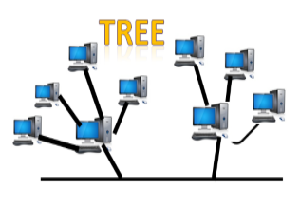

* Tree topology combines the characteristics of bus topology and star topology.
* A tree topology is a type of structure in which all the computers are connected with each other in hierarchical fashion.
* The top-most node in tree topology is known as a root node, and all other nodes are the descendants of the root node.
* There is only one path exists between two nodes for the data transmission. Thus, it forms a parent-child hierarchy.

### Advantages of Tree topology

* Support for broadband transmission: Tree topology is mainly used to provide broadband transmission, i.e., signals are sent over long distances without being attenuated.
* Easily expandable: We can add the new device to the existing network. Therefore, we can say that tree topology is easily expandable.
* Easily manageable: In tree topology, the whole network is divided into segments known as star networks which can be easily managed and maintained.
* Error detection: Error detection and error correction are very easy in a tree topology.
* Limited failure: The breakdown in one station does not affect the entire network.
* Point-to-point wiring: It has point-to-point wiring for individual segments.

### Disadvantages of Tree topology

* Difficult troubleshooting: If any fault occurs in the node, then it becomes difficult to troubleshoot the problem.
* High cost: Devices required for broadband transmission are very costly.
* Failure: A tree topology mainly relies on main bus cable and failure in main bus cable will damage the overall network.
* Reconfiguration difficult: If new devices are added, then it becomes difficult to reconfigure.

## Mesh topology

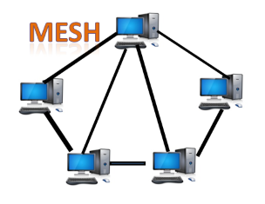

* Mesh technology is an arrangement of the network in which computers are interconnected with each other through various redundant connections.
* There are multiple paths from one computer to another computer.
* It does not contain the switch, hub or any central computer which acts as a central point of communication.
* The Internet is an example of the mesh topology.
* Mesh topology is mainly used for WAN implementations where communication failures are a critical concern.
* Mesh topology is mainly used for wireless networks.
* Mesh topology can be formed by using the formula:  
  Number of cables = (n\*(n-1))/2;